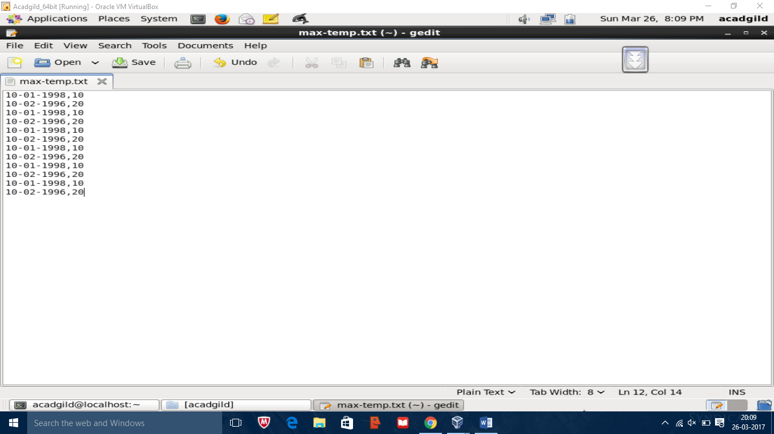

Max-temp.txt with 10 records is created

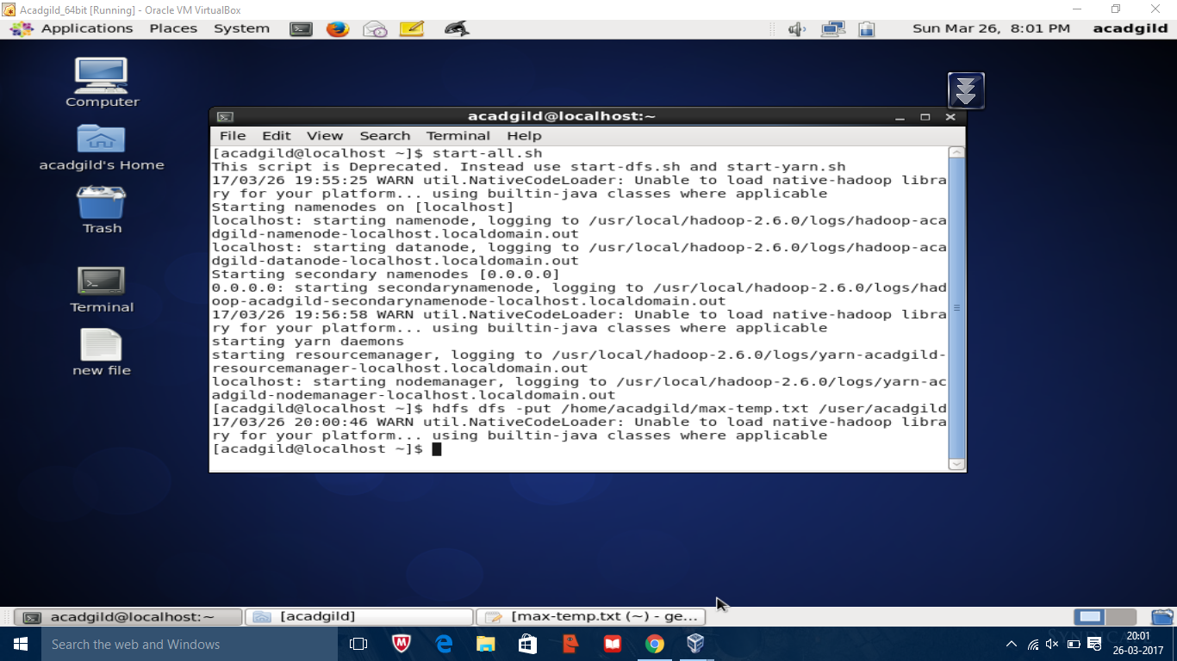

Creating max-temp.txt and inserting into hdfs

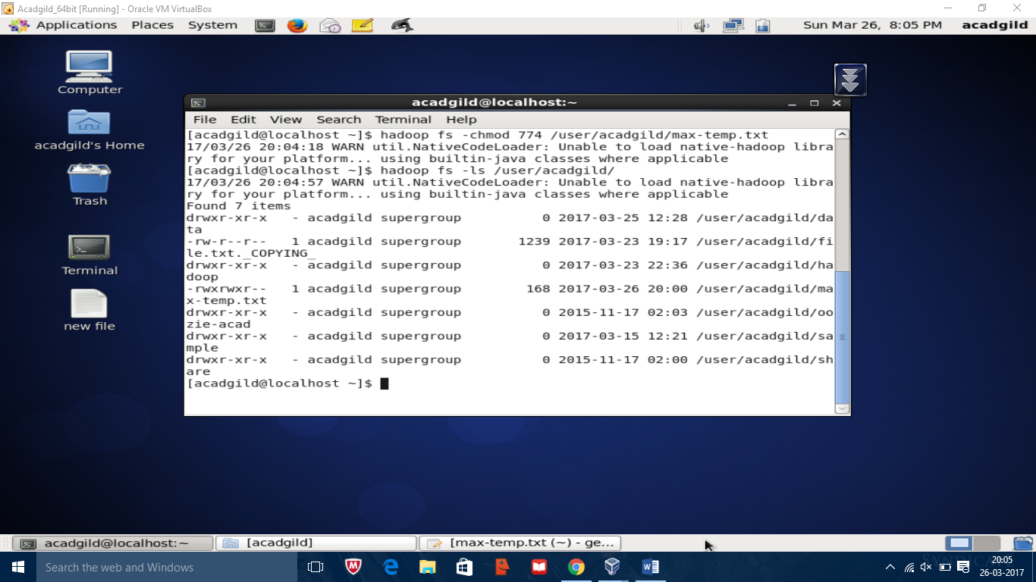

The max-temp.txt file is given r-w-x permission using the following command hadoop fs –chmod /user/acadgild/max-temp.txt.